Growing Fruit
The thought of growing your own fruit can be daunting—refer to this handout for some beginner guidance!
Blueberries
Blueberries can be fairly easy to grow—they are low-maintenance and require little care or pruning. Bushes do well in smaller spaces, making it easy to find a spot to grow them!
Types of Blueberries
Highbush (Vaccinium corymbosum): grows upright, usually 4-6 feet tall, and 3-6 feet wide. They are self-fruitful. Hardy in zones 4-7. Highbush is the type of blueberry that is recommended to grow in Ohio.
Half-High (Vaccinium angustifolium): This is a hybrid between highbush and lowbush varieties. They are more compact than highbush, growing about 2-4 feet tall, but are also self-fruitful, producing slightly smaller fruit. Hardy in zones 3-7. Half-high may not be as productive as highbush in Ohio.
Bloom Times
Blueberry varieties can be early, mid, or late season. Growing varieties with different bloom times can improve pollination and a bigger harvest.
Early Season Varieties: Duke, Patriot, Spartan
Mid-Season Varieties: Bluecrop, Blueray, Jersey, Reka, Top Hat
Late Season Varieties: Liberty, Elliot
Care Tips
Blueberries like full sun (6 or more hours of sunlight).
They grow best in well-drained, acidic soil—a soil acidifier or fertilizer like Espoma Berry-tone may be used to acidify soil.
Bushes should not be pruned until they are established (at least 4 years old). Late winter/early spring is the best time to prune by removing the weakest, oldest branches.
Protect bushes by discouraging deer and birds—netting can be used to shield them.

Bramble Berries
Raspberries and Blackberries are easy to grow in either a landscape or a container. While these brambles are generally considered prickly, many newer varieties are bred to be thornless.
Raspberries
Red raspberries are the most popular, producing fruit in the summer and having many varieties to choose from. Raspberries should be planted about 3-5 feet apart. They are self-fruitful but produce more with multiple varieties around them.
Popular Raspberry Varieties: Boyne (early season red raspberry), Bristol (mid-season black raspberry), Encore (late season red raspberry), Jewel (mid-season black raspberry), Latham (mid-season red raspberry).
Blackberries
Blackberries need a little more space than raspberries, as they grow slightly bigger. They should be planted in a sunny spot away from raspberries, about 5 feet apart from each other.
Popular Blackberry Varieties: Chester Thornless (late season thornless blackberry), Navaho (thornless blackberry), Twilight (thornless blackberry).
Care Tips
Raspberries and Blackberries grow best in full sun (6 or more hours of sunlight).
They like well-drained, slightly acidic soil—a soil acidifier or Espoma Berry-tone could be used. Covering shrubs with netting can protect them from bird or deer damage.
In the fall, canes can be cut to the ground when harvest is done for the season. In early spring, weak or damaged branches can also be removed. Canes can be thinned so that each plant has about 4-6, spaced out. Brambles usually produce fruit on second-year canes.

Apples
Apples are a great addition to the landscape, offering pretty spring blooms then fruit from late summer into fall. Trees grow moderately and usually produce fruit within 2 to 5 years.
Pollination
Most apple varieties need a second tree that blooms at the same time for cross-pollination. Crabapples can be a good choice for pollination, as they have a lot of pollen and bloom for a long time. Below is a chart of varieties with their recommended pollinators (J. Frank Schmidt & Son Co.)
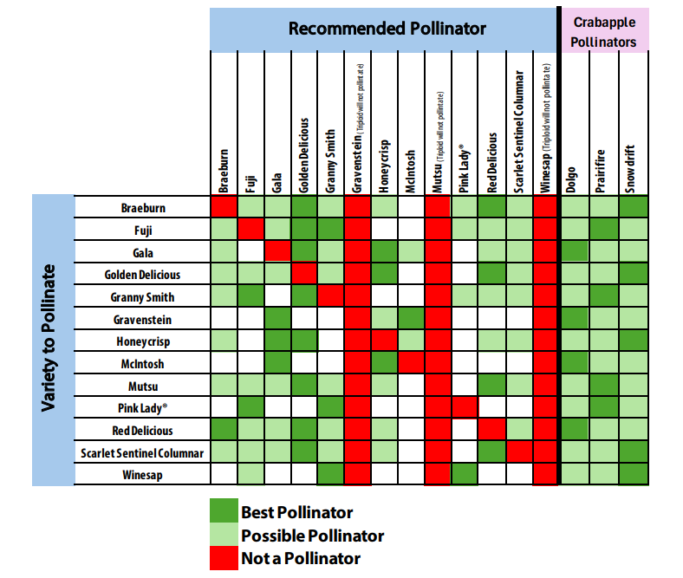
Care Tips
Apples grow best in full sun and well-drained soil.
Giving trees plenty of space to grow also allows for air circulation that can help prevent disease. Make sure that plants are close enough to pollinate each other (within 100 feet).
Pruning in late winter can help maintain shape. After planting, it helps to use a slow-release fertilizer, usually once in early spring and once in mid-summer (following directions on the label).

Fruiting Cherry
Cherries, similar to Apples, are popular in landscapes for their spring blooms and fruit produced in the summer.
Sweet and Sour
The most common fruiting cherries grown are sweet (Prunus avium) and sour (Prunus cerasus). Both begin producing fruit within 3 to 5 years.
Sweet cherries produce large fruit. These need cross-pollination and should be planted near another tree to yield fruit.
Tart cherries are self-pollinating, but harvest will improve with another similar cherry nearby.
Sweet Cherry Pollination
- Bing is compatible pollinating with Rainier, Stella, or Montmorency (which is a tart cherry).
- Lambert is compatible with Stella, Rainier, Montmorency.
- Rainier is compatible with Bing, Royal Ann, Montmorency, Stella
Care Tips
Sweet cherries are better planted in a protected site with well-drained soil and winter protection.
Tart cherries grow well in Ohio; they tend to stay smaller than sweet cherries.
Both types grow well in full sun (6 or more hours of sunlight).
Pruning in winter helps to control size. After planting, it helps to use a slow-release fertilizer, usually once in early spring and once in mid-summer (following directions on the label).

